BITS Pilani, Dubai Campus

Dubai International Academic City, Dubai

I Semester 2020-21

CS F222 Discrete Structures for Computer Science

Assignment - II

ID No: 2019A7PS0020U

Name: Dhruv Maheshwari

Section No: 2

Ques No: 21

Ques Statement: Write a program that generates all combinations of the elements {1, · · · , n}.

Output file

Example 1:

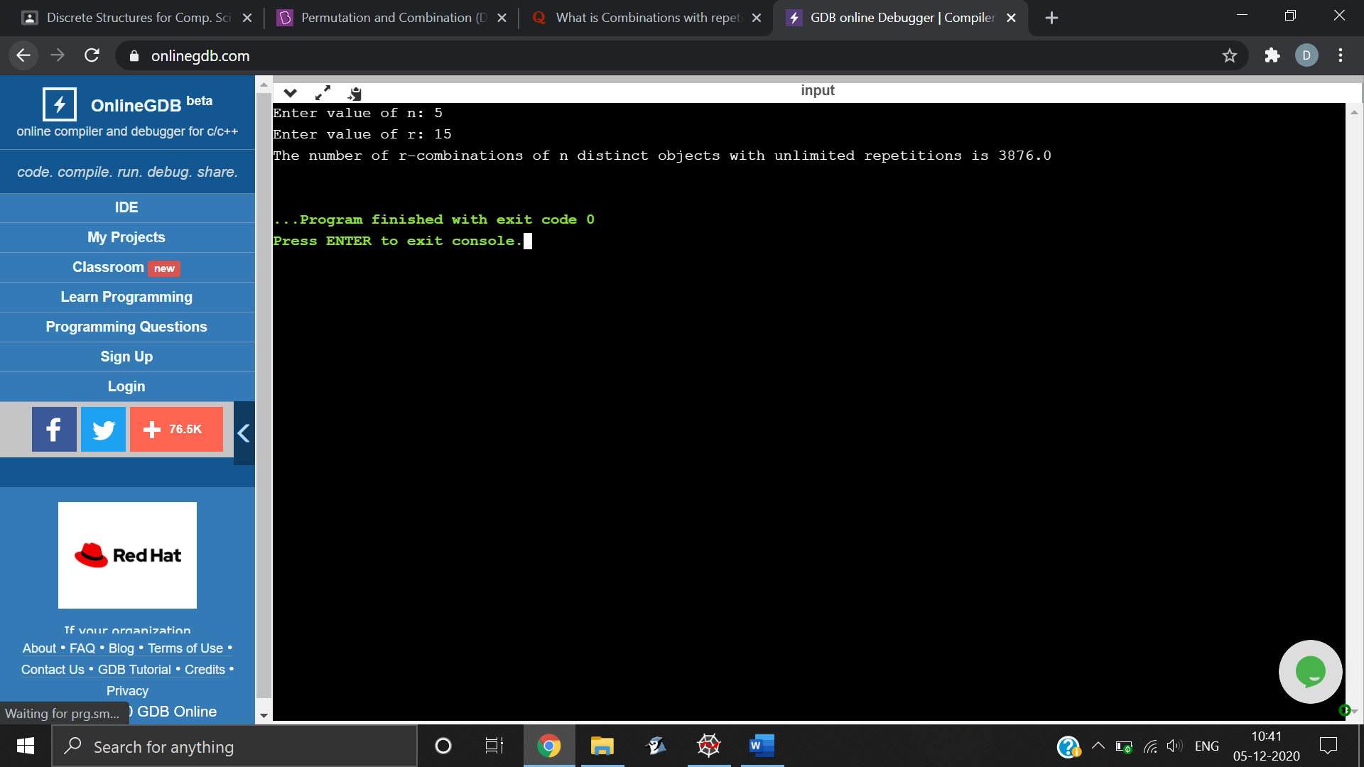

Example 2:

